Assignment: JavaScript Exercise, Part 4
For this assignment, you will add JavaScript capability to previous code. You won't need to create a separate JavaScript file, but you can if you like. If you do use a separate .js file, you'll either need to put that array in the .js file, or do research on how to pass arrays in JavaScript, which is not the easiest task. You'll need two buttons. You do not need to follow the example in page design in terms of button placement or size or color, feel free to be creative.

Assignment Details:
1. Assignment Instructions
- Create a new folder under your local csd-340 folder (repository) and name it module-12
- Make a copy of LastName_Mod3_3.html and add it to your module-12 directory. Rename the file to LastName_Mod12_2.html
- Add a link in the index.html file to the new LastName_Mod12_2 HTML file
  - Hint: Refer back to assignment 4.2 if you are confused on what this item is referencing
- Contents of LastName_Mod12_2.html
  - Make sure HTML page title says "CSD 340 Web Development with HTML and CSS"
  - Rename the h1 text value to "Assignment 12.2: JavaScript - Part 4"
  - Take the current list of your top ten books, place the book titles into an array.
  - Create two buttons. One button should be labeled "Top to Bottom", the other button should be labeled "Bottom to Top".
  - Create a javascript section. Add two functions; one for displaying the array elements in ascending order, the other to display the array elements in descending order.
    - When the 'Top to Bottom' button is clicked, the contents of the array should be displayed in ascending order.
    - When the 'Bottom to Top' button is clicked, the contents of the array should be displayed in descending order.
2.Browser Output Example
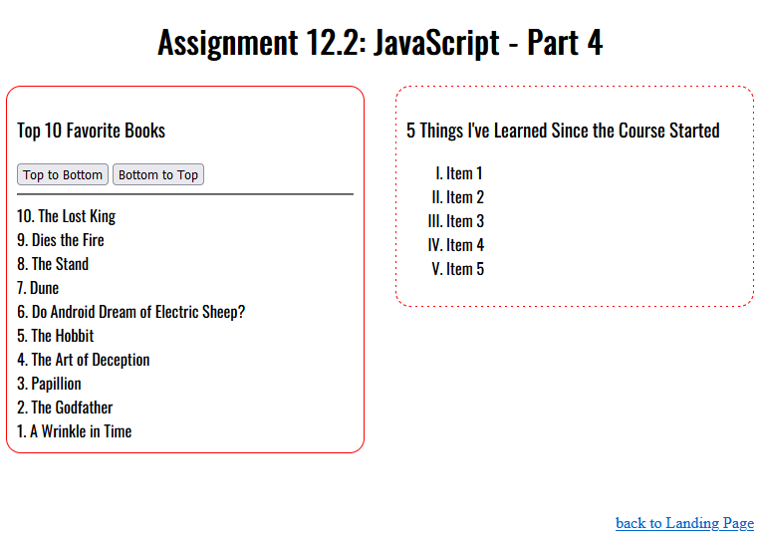
3. GitHub
- Stage, commit, and push your work to GitHub.
  - Click on the following link for instructions: GitHub Stage, Commit, and Push.pdf
4. Deliverables
- URL to your repositories GitHub pages website
- module-12 directory packaged as a .zip file

Assignment Requirements and Grading:
- This assignment is due by Sunday, 11:59 p.m., CST.
- Submit your assignment by clicking on the Assignment Link above, then scroll down to the Attach Files section and click on Browse My Computer. Select your assignment file, add any links or comments as appropriate, and then click on Submit.
- To view the grading rubric for this assignment, click on the following link: Programming Grading Rubric.
(50 points)

